Saint Louis’ nobility of spirit
FEAST DAY: August 25th
OFS Monthly Formation August 2022

The Holy Gospel: Luke 22:27
Our dear Lord said, “I am among you as one who serves”. From a Christian point of view, one who serves, reigns, which contrasts with a more worldly perspective of desiring to reign or rule by way of domination and oppression. The truth of the Gospel is self-evident in that Our dear Lord and His most Blessed Mother (see Luke 1:38), reign as our heavenly King and Queen respectively, for they were truly servants of God the Father.

Our Patron, Louis IX, a King, and a Saint
Saint Louis IX of France, our OFS Patron, was a notable example of a King who served and was particularly noted for his Franciscan “spirit of penance and prayer and his love for the poor”. In his Spiritual Testament this noble spirit of a true servant of God is evident as he writes to his son, “my dearest son, I exhort you above all else to love the Lord your God
with your whole heart and with all your strength; there is no salvation apart from this. Keep yourself free from everything you know to be displeasing to God, that is, from every mortal sin. You must be willing to suffer any kind of martyrdom rather than commit a grievous sin. Furthermore, if God wills that you endure some trial, accept it lovingly and gratefully. Remember that it happens to you for your own good and that you may very well have deserved it. If on the other hand the Lord bestows good fortune on you, humbly thank him, and take care not to become worse because of it. Avoid vain glory too, lest you offend God through the blessings he grants you. Attend the services of the Church Saint Louis IX of France (1214-1270) willingly and devoutly, and while in church take care not to let your eyes wander. Guard against idle conversation and pray to God devoutly in oral prayer and pious meditation. Be kindly disposed toward the poor, the wretched and afflicted; help them as much as you can and console them. Thank God for all the blessings he has bestowed on you so that you may be worthy to receive greater ones. Be just towards your subjects; in matters of justice adhere to the line, departing neither to the right nor to the left. Incline to the poor man’s side rather than to the rich man’s until you are certain where the truth lies. Take care that all your subjects are safeguarded in justice and peace, especially ecclesiastics and religious. Be devoted and obedient to our mother, the Church of Rome, and to the Supreme Pontiff as your spiritual father. Work to eradicate all sin from your country, especially blasphemy and heresy. Finally, my son, I bestow on you every blessing a loving father can give his son. May the Blessed Trinity and all the saints protect you from all evil. The Lord grant you the grace to do his will in such a way as to deserve him and honor him; and after this life may we both meet to see, love and praise him without end. Amen.” (Source: Proper Offices of Franciscan Saints and Blessed in the Liturgy of the Hours, August 25th, Office of Readings, 2nd Reading).

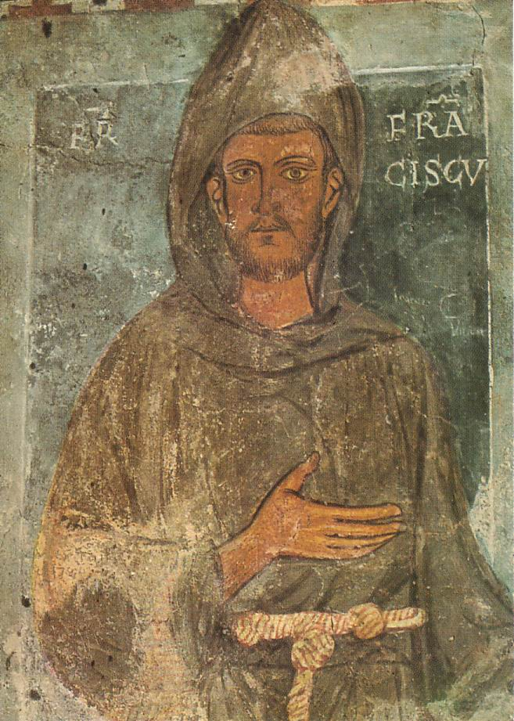
General Constitutions
In Title II on the ‘Active presence of Secular Franciscans in the Church and in the World’, Article 20, 2 states “as the primary and fundamental contribution to building a more just and fraternal world, they should commit themselves both to the generous fulfillment of the duties proper to their occupation and to the professional training that pertains to it. With the same spirit of service, they should assume their social and civil responsibilities.

Oldest known portrait of St. Francis, a mural painting in the sacred grotto of St. Benedict’s Cave in Subiaco, Italy (dating back to his retreat there in 1223-1224).

Something to ponder
St Francis states “I prayed that God would deign to show me when it is I am his servant and when not, for I want nothing else but to be his servant. And the Lord answered most graciously: ‘Know that you are truly my servant when you think, do, and say what is
holy’” (Mirror of Perfection, 74).

The Church
Saint Louis IX was both a servant and holy, as the Church has acclaimed him a Saint. As the Lord gave Saint Francis to understand, holiness and servanthood are indeed closely related and the Church would also affirm this. In reference to the universal call to holiness, Lumen Gentium 40 states “that all the faithful of Christ of whatever rank or status, are called to the fullness of the Christian life and to the perfection of charity; by this holiness as such a more human manner of living is promoted in this earthly society. In order that the faithful may reach this perfection, they must use their strength accordingly as they have received it, as a gift from Christ. They must follow in His footsteps and conform themselves to His image seeking the will of the Father in all things. They must devote themselves with all their being to the glory of God and the service of their neighbor. In this way, the holiness of the People of God will grow into an abundant harvest of good, as is admirably shown by the life of so many saints in Church history”.

Let us pray: In whatever environment we find ourselves in life, may the spirit of true service, permeate our thoughts, words, and deeds, that we may reflect the holiness of God. This we ask through the intercession of St. Louis, our Patron, in Jesus name. Amen.

