Peace and all good

OFS Monthly Formation March 2022
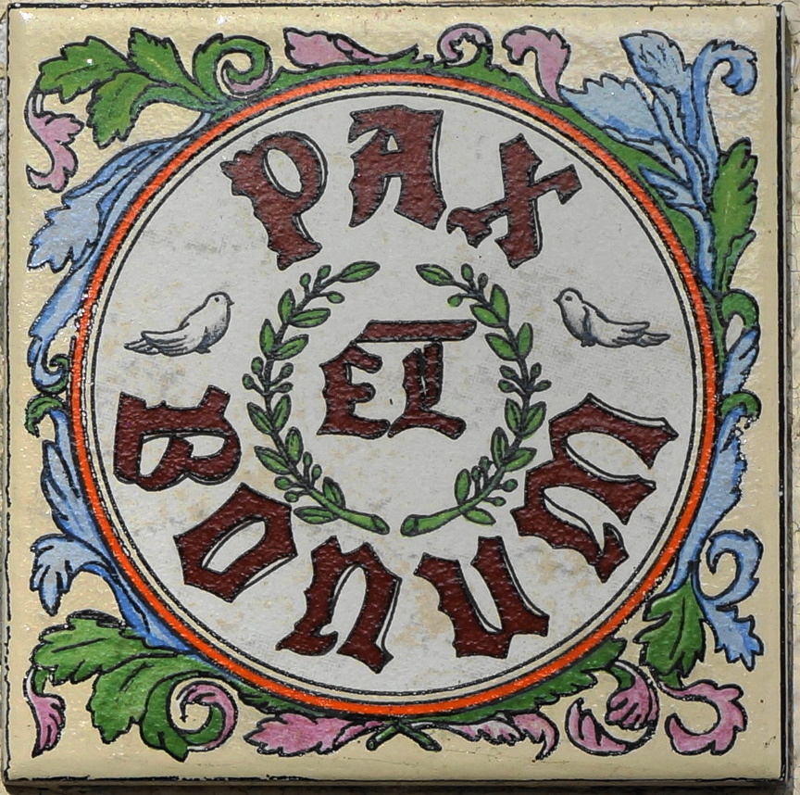
Pax et bonum:
The song ‘Make me a channel of your peace’ is well known in our Church circles. It relates well to the Franciscan message of ‘pax et bonum’, which literally translates from the Latin to ‘peace and goodness’. Yet, the thought occurs what does this peace really mean, in terms of inner and even outer peace? Saint Francis was born into a time of war amongst neighbouring towns, and he experienced the opposite of peace, which providentially became a significant influence in his wholehearted conversion to Christ and to becoming a man of peace himself.

The Rule of the OFS, 19:
“Mindful that they are bearers of peace which must be built up unceasingly, they should seek out ways of unity and fraternal harmony through dialogue, trusting in the presence of the divine seed in everyone and in the transforming power of love and pardon”.

General Constitutions of the OFS - Article 22,3:
“The renunciation of the use of violence, characteristic of the followers of Francis, does not mean the renunciation of action. However, the brothers and sisters should take care that their interventions are always inspired by Christian love”.

The Gospel on peace:
In Luke Chapter 10 verse 5, Christ’s admonition to the seventy disciples, prior to going out on their mission, was “whatever house you enter, first say, ‘Peace be to this house!’”. In the Gospel of John, prior to His Passion, in chapter 16 verse 33 He states, “‘that in me you may have peace. In the world you have tribulations, but be of good cheer, I have overcome the world’”. Then after the resurrection in chapter 20 verse 19, Jesus says to his fearful disciples, “‘peace be with you’”.

Something to ponder:
What exactly is it that may break our peace and disturb our inner tranquillity? Is it our worries and fears, anger in our heart, our neighbours, our relatives, the Government, world politics? Is there a kind of war that exists in the human soul, that is, a struggle to reconcile with Christ’s call to be people of peace? History testifies that St. Francis, the man of peace, had a way of overcoming these disturbances. He had answers from the Gospel that he took to heart and lived heroically. He was a man deeply transformed by the Holy Spirit; peace being a fruit of the Spirit (Gal. 5:22). Francis was also a man of deep prayer. He lived in turbulent times but was able to dive deep in prayer into the stillness of God’s presence (rather like someone diving down below into the silence at the bottom of the ocean, to remove oneself from the turbulent waters on the surface). So, is it the presence of violence and evil in the heart, the opposite of good, that breaks our peace, thus peace and goodness cannot exist, one without the other? Does goodness in the heart, a heart transformed by God’s Spirit, the Holy Spirit of love, therefore lead to peace, personally, fraternally, universally?

St Francis:
The Spirit of the Gospel, the Spirit of Christ pervaded Francis’s soul, his words, thoughts, and actions. St. Francis therefore had inner peace, that presence of the Holy Spirit. By the grace of God, he had integrated the Gospel truths into the way he lived. St. Francis was known to say in his greetings to others “May the Lord give you peace”, because the Lord had revealed this truly wise greeting to Francis. There is a statue of St. Francis near the rose garden of the Basilica of Saint Mary of the Angels, in Assisi, where quite miraculously, as you will see below, doves (being a universal symbol of peace and a Christian symbol of the Holy Spirit) would come and rest. Truly St. Francis lived what he preached and preached by the way he lived, so much so, that even creatures gave witness to it.

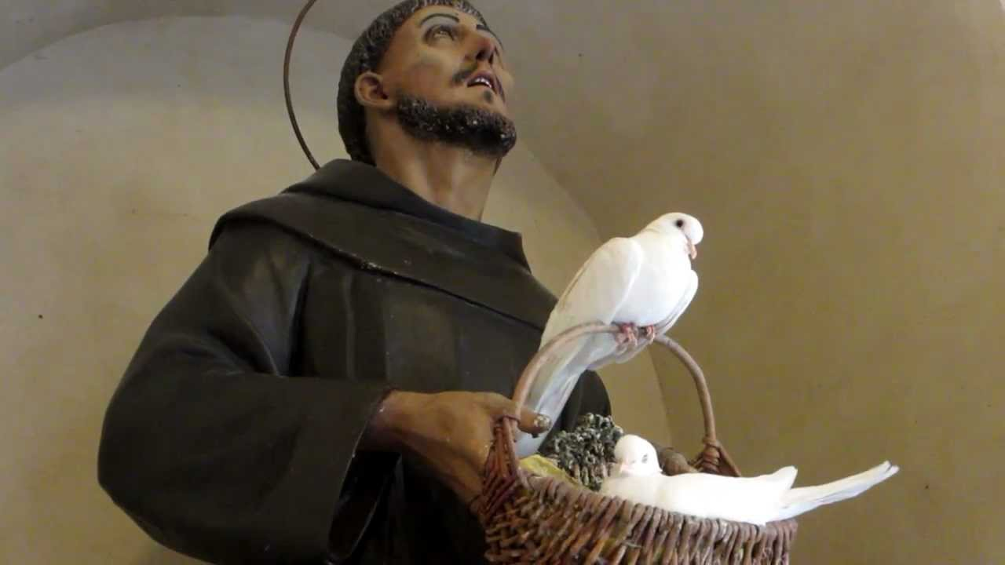

Francis’s own admonition for peacemakers, from the Legend of the Three companions, 58, was that “‘the peace which you proclaim with words must dwell even more abundantly in your hearts. Do not provoke others to anger or give scandal. Rather, let your gentleness draw them to peace, goodness, and concord. This is our vocation: to heal wounds, to bind what is broken, to bring home those who are lost. And remember that many who may now seem to be of the devil can one day become disciples of Christ’”.

Prayer:
As Christians, it is Christ who is our peace, as we are told in scripture, and it is through His cross, that Christ our peace has reconciled us to God. So, let us pray, in the spirit of St Paul’s exhortation to the Philippians (4:6-7), that the peace of God which transpasses all understanding will guard our hearts and minds in Christ Jesus. Amen.

