‘Become a living prayer’

OFS Monthly Formation August 2021
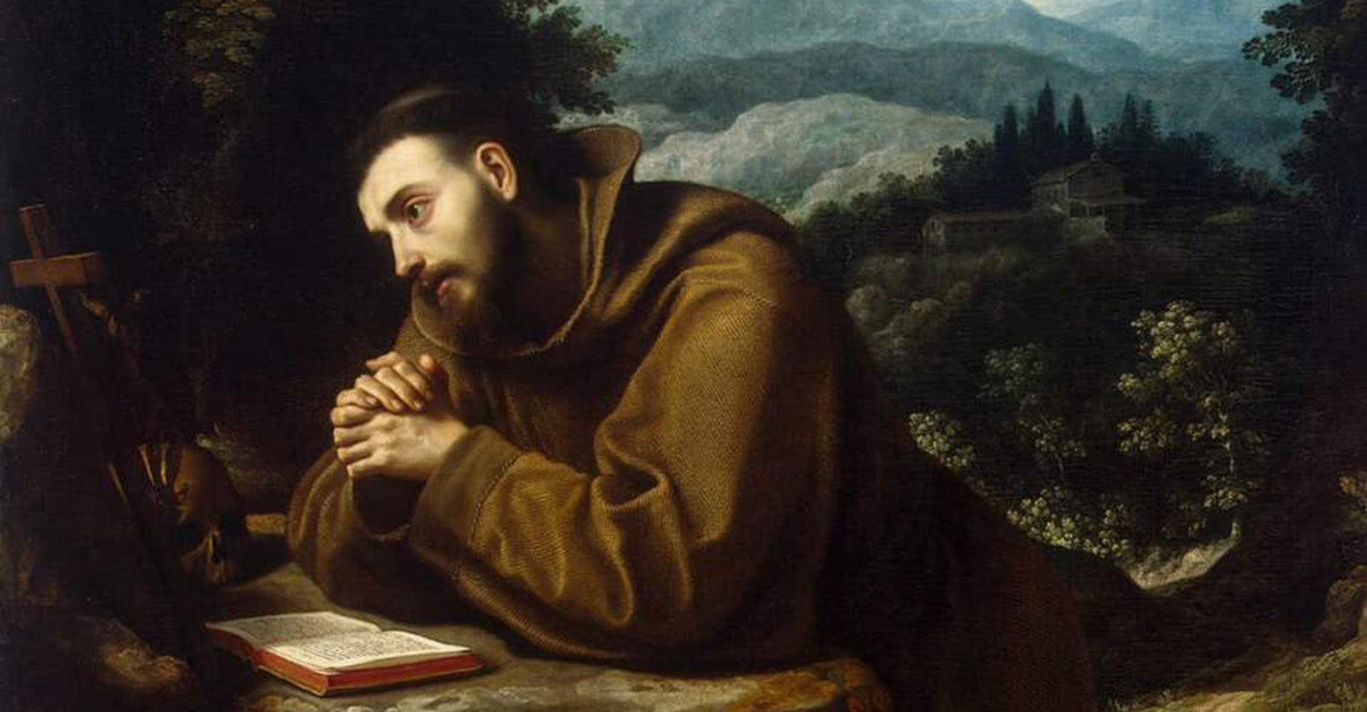
St Francis in Prayer

Have you ever looked at someone and in doing so, it was like seeing a prayer? Well, if you looked at St Francis, that is what you would see.

St Francis at Prayer:

“Often, without moving his lips, St Francis would meditate for a long time and, concentrating, centring his external powers, he would rise in spirit to heaven. Thus, he directed his whole mind and affections to the one thing he was asking of God. He was not then so much a man who prayed, as a man who had become a living prayer”. Celano, Second Life, 95.

The words of the Servant of God, Catherine de Hueck Doherty (Third Order Franciscan):

“If we pray to the Holy Spirit, and then forget we are praying because we have become immersed in him, ‘we become a prayer’”. (Poustinia, p. 181)

St Francis writes:
“The friars to whom God has given the grace of working should work in a spirit of faith and devotion and avoid idleness, which is the enemy of the soul, without however extinguishing the spirit of prayer and devotion, to which every temporal consideration must be subordinate” (1223 Rule, 5).

The Gospel:
As Franciscans, called to go from Gospel to Life and Life to Gospel, consider the words of Saint Paul, the Apostle:

1 Thessalonians 5:16-18 “Rejoice always, pray constantly, give thanks in all circumstances; for this is the will of God in Christ Jesus for you”.

Does this scripture, not describe St Francis, always praising God, giving thanks, and praying.

A point of reflection:
In Paragraph 4 of Fratelli Tutti, (On Fraternity and Social Friendship), Pope Francis states that “Francis did not wage a war of words aimed at imposing doctrines; he simply spread the love of God. He understood that ‘God is love and those who abide in love abide in God’ (1 Jn 4:16)” and that “Francis was able to welcome true peace into his heart and free himself of the desire to wield power over others”. Indeed, the thought comes to mind, that the man of peace and love (St. Francis) is one who is in union with God, abiding in the Spirit of God, through unceasing prayer.

So, let us pray:
That through the intercession of St. Paul and St. Francis, no matter what our circumstances, we would not ‘quench the spirit’, but through constant prayer and thanksgiving, become a living prayer, Amen. (1 Thes. 5:19)

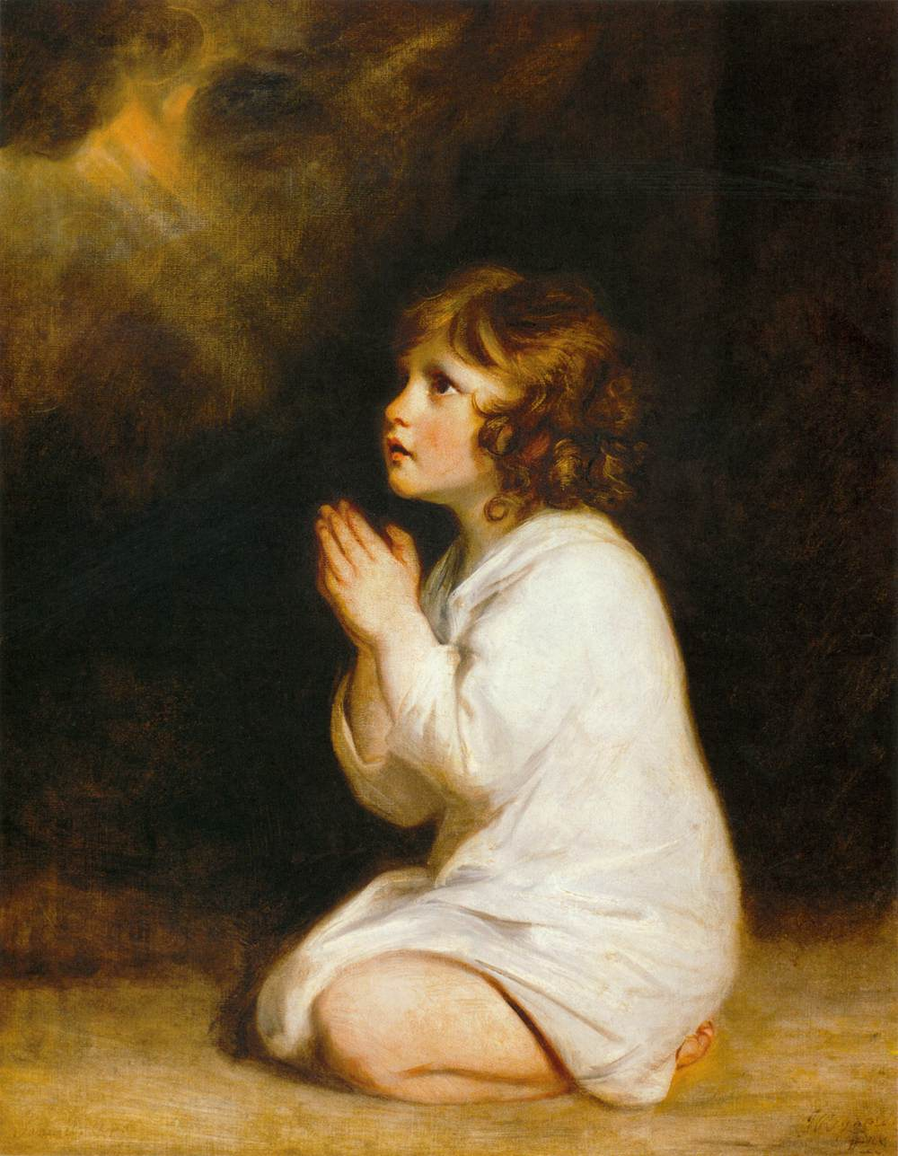
The infant Samuel at prayer by Reynolds

