OFS - A Saintly Line

OFS Monthly Formation February 2022

You may recall, attending a school sports day and being aghast when it came to your turn to do the high jump, that they raised the bar even higher. Perhaps that was the reaction of some of the faithful following the ‘universal call to holiness’ expounded in Vatican II’s Lumen Gentium. This made it very clear, that it was not only priests, nuns and monks that are called to be holy, but all the faithful. There are many outstanding examples of holiness in our Franciscan History of yesteryear, yet what is also most heart warming is that there are modern-day OFS Saints, from whom we can learn something about this universal call.
In the Prologue to the Rule, Chapter One, Saint Francis reminds us of our Lords high priestly prayer to the Father, for the disciples “‘that they may be holy by being one as we are (cf. Jn. 17,11)’”.
Scripture:
In 1 Peter 1:15 it states, “as He who called you is holy, be holy yourselves in all your conduct, since it is written, ‘You shall be holy for I am holy’”. (cf. Lev. 11.44-45)

OFS Saints:
As OFS, we are called to be in the world, but not of the world.
Following, are two examples, an OFS woman and an OFS man, who individually have taken the above words of scripture very much to heart and have been recognised by the Church as having reached great heights of sanctity. Meanwhile I would imagine there are other OFS throughout the world who have lived holy lives too, in a quiet hidden way, known only to God, and perhaps a close few.

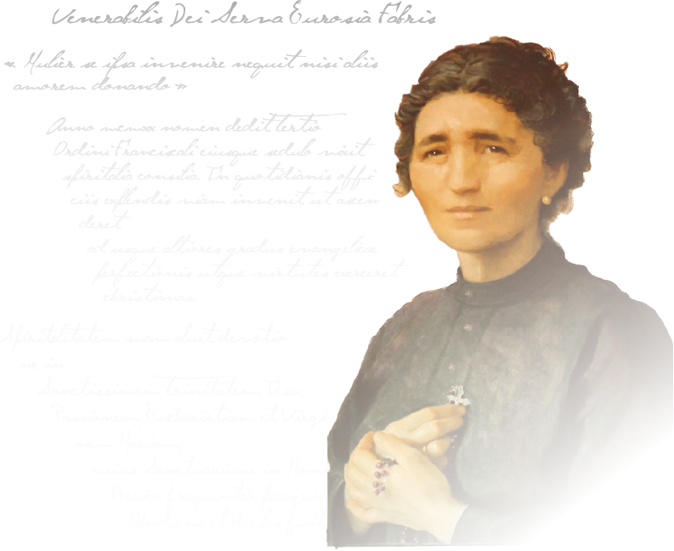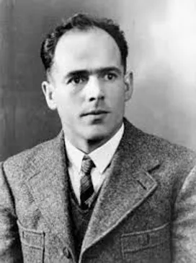
Bl. Eurosia Fabris Barban Bl. Franz Jagerstatter
Laywoman (Died 8 Jan, 1932) Layman & martyr (Died 9 Aug, 1943)
Blessed Eurosia Fabris Barban, was a married Italian woman, who adopted 2 orphan babies (prior to marriage) and had 9 children of her own. In terms of her commitment to the OFS, “she faithfully attended all their meetings, but above all tried to live the true Franciscan spirit of poverty and joy in her home, in the midst of her daily work and prayer”. She “sacrificed and consumed herself day by day like a lamp burning brightly on the altar of charity” and she “was a model of holiness in what should be the daily life of a Catholic family. Her three sons who became priests were encouraged in their vocation by her example of holiness”. (Sourced from the Vatican News Services).
Blessed Franz Jagerstatter was an Austrian farmer, married with three daughters. “In 1938 he was the only local citizen to vote against the ‘Anschluss’ (annexation of Austria by Germany), because his conscience prevailed over the path of least resistance”. Then in his final call to military service in the German Army of WWII, he refused to fight. As a conscientious objector he was thus martyred. Prior to his execution he wrote; "if I must write... with my hands in chains, I find that much better than if my will were in chains. Neither prison nor chains nor sentence of death can rob a man of the Faith and his free will. God gives so much strength that it is possible to bear any suffering”. (Sourced from the Vatican News Services) Bl. Franz’s story, a movie entitled “A hidden life”, can be viewed at: - https://gloria.tv/post/XTJRXfLqiCxf1L6YeRcCr83Ju.
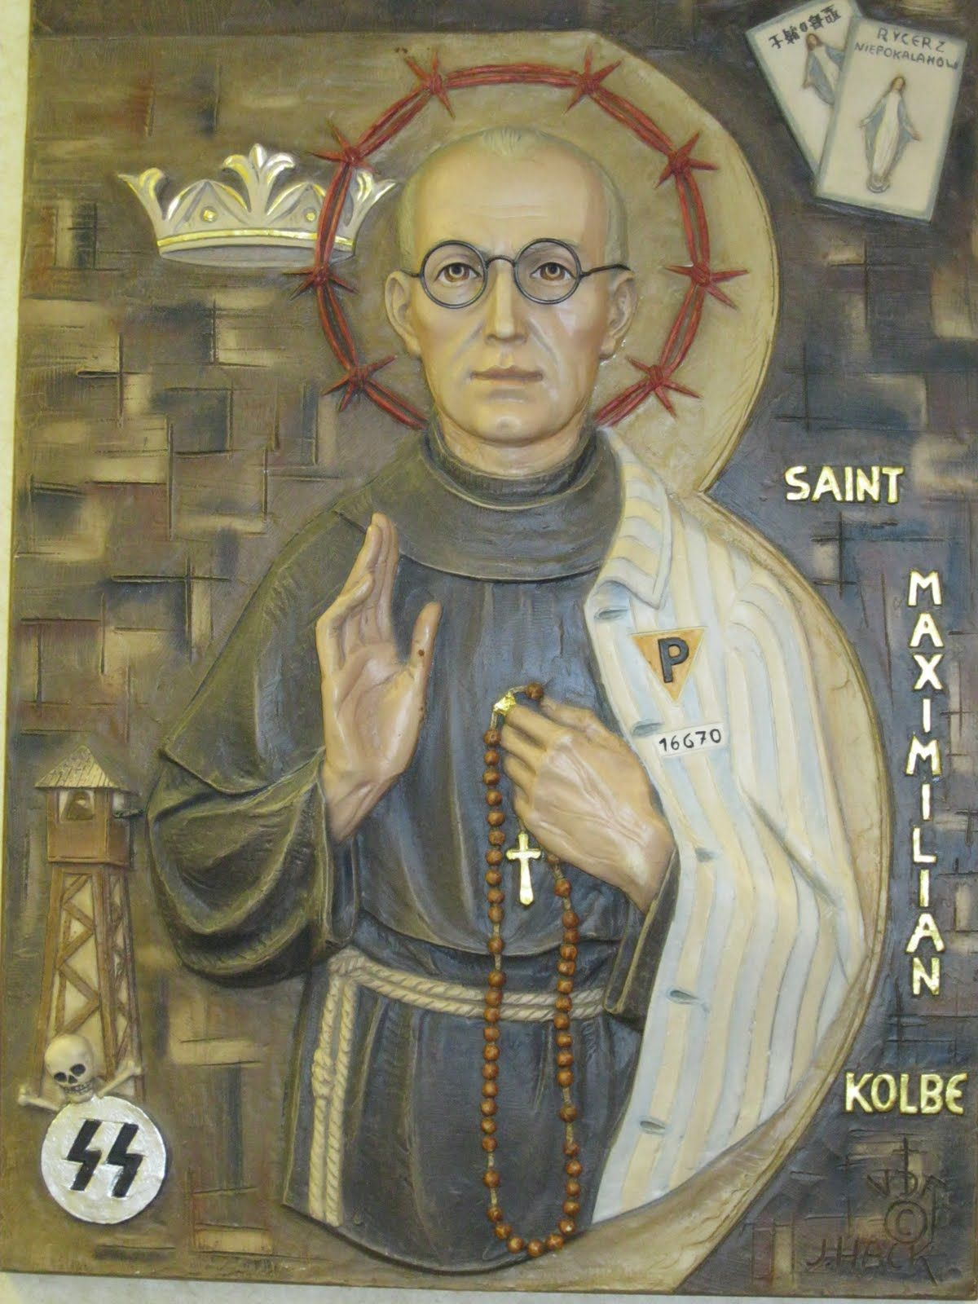
Holiness: Saint Maximilian Kolbe writes that “only Jesus, by coming into the world, showed humanity the way to true holiness, by example and word. The essence of holiness consists in loving God to the point of heroism. Its hallmark is the fulfillment of God’s will, especially as expressed in the commandments of God and of the Church in the duties of one’s state of life. Its means are (1) continuous self-vigilance in order to know one’s flaws and uproot them, engraft the virtues, cultivate them, develop them to higher degrees; and (2) prayer, whereby the soul obtains God’s supernatural graces, indispensable to spiritual progress. In all saints, prayer takes a prominent place”. (Kolbe Writings 1001, March 1922)

Let us pray, through the intercession of Bl. Eurosia, Bl. Franz, and St. Maximilian Kolbe, for the grace to reach the heights that God has called us to. Amen.

