The Holy Name of Jesus

OFS Monthly Formation January 2022

Church Liturgy:
It has been a tradition of the Church to dedicate the month of January to the Holy Name of Jesus. On January 3rd, the Church celebrates the Feast of the Holy Name of Jesus.

Saint Francis:
It would appear, that Saint Francis had a great devotion to the Holy Name of Jesus, for Celano writes that when St. Francis said the name of “‘Jesus’, his tongue licked his lips, as if he were savouring the sweetness of the words”.

Scripture: Philippians 2:5 - 11
“Have this mind among yourselves, which was in Christ Jesus, who, though he was in the form of God, did not count equality with God a thing to be grasped, but emptied himself, taking the form of a servant, being born in the likeness of men. And being found in human form he humbled himself and became obedient unto death, even death on a cross.
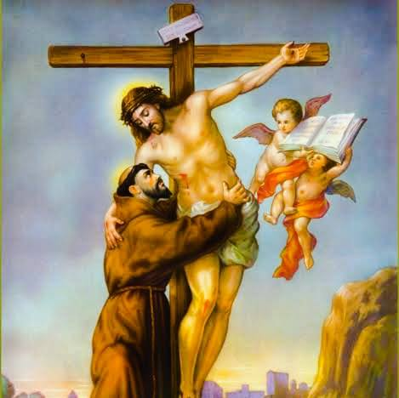

Therefore God has highly exalted him and bestowed on him the name which is above every name, that at the name of Jesus every knee should bow, in heaven and on earth and under the earth, and every tongue confess that Jesus Christ is Lord, to the glory of God the Father.”

The above passage of scripture not only gives reverence to the name of Jesus, but also the aspect of imitating Christ’s humility. Indeed, from the Crib to the Cross, Christ humbled himself. What humility, that Jesus, Our Lord and Saviour, entered our world as a little babe, so vulnerable to humanity and yet He is the one who is all powerful, as demonstrated is this beautiful and well known story of Saint Clare of Assisi and the protection of the Child Jesus.

Saint Clare was seriously ill and could not rise from bed, when some Saracens, who had been attacking and pillaging the surrounding towns, approached San Damiano, the convent Saint Francis had given to Saint Clare and her Nuns. Her Sisters came running to her in a panic. They cried, they feared for their lives; they could see the Saracens approaching, and they didn’t know what to do. Clare summoned two Nuns to help her out of her bed and assist her, as she struggled to get to the Tabernacle where Our Lord Jesus resided, truly Present in the Most Holy Eucharist. She carefully removed the Monstrance from the Tabernacle containing His Majesty, and pressing it against her head, she prayed. Then, walking over to the open window she beseeched the Lord, “Protect, Lord, these your servants, that I now, by myself, cannot protect.” A very sweet young voice, that of a young Child, answered, “I will take care of you always.” Feeling confident, Clare added another prayer, “My Lord, protect also, if it pleases You, this city that by Your Love supports us.” Our Lord responded to His bride Clare, “It will have to go through suffering, but it will be defended by My protection.”
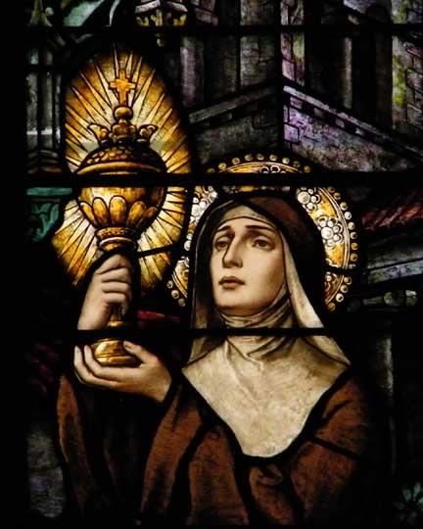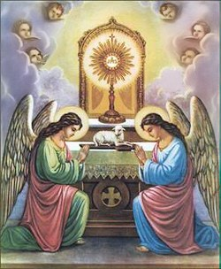
In the Prologue to the Rule, Chapter One, St. Francis says, “Oh, (how glorious it is) to have such a brother and such a Son, loved, beloved, humble, peaceful sweet, loveable, and desirable above all: Our Lord Jesus Christ..”.
Let us pray, that we may honour the sweet name of Jesus and adore our Saviour, in the Most Holy Eucharist, who humbled Himself to dwell amongst us. Amen.

