‘The Pure in Heart’

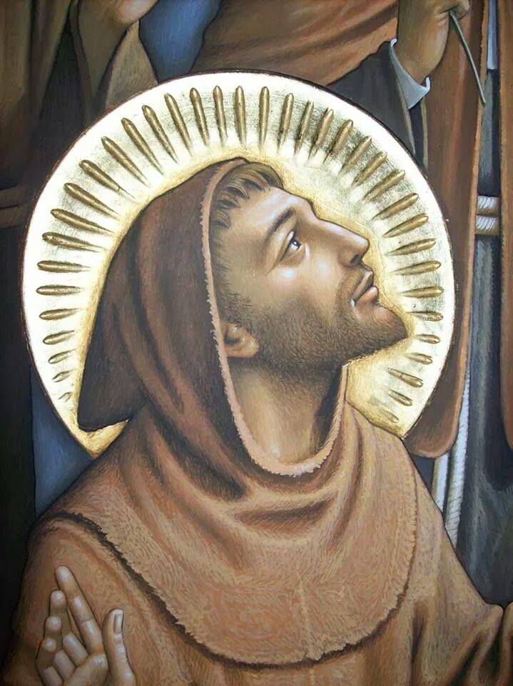

OFS Monthly Formation July 2021

The words of Saint Francis:
“A devout and powerful king sent two messengers, one after another, to his queen. The first returned and related the queen’s reply without saying a word about the queen; he had wisely averted his eyes and did not look upon the queen. The other also returned, and after a rather brief message, he embarked upon a long eulogy to the queen’s beauty. ‘Indeed, sire,’ he concluded, ‘I have seen a most beautiful woman; happy is he who can enjoy her!’
But the king answered him: ‘Unworthy servant, you’ve been sliding your filthy glances over my queen! It is clear that you’d like to possess what your eyes have violated.’
Then he called back the first messenger and said to him, ‘How did the queen seem to you?’ But the messenger answered, ‘I don’t really have a clear picture of her, sire, except that she listened willingly and with patience.’
And the king, ‘Did she strike you as a beautiful woman?’
‘Sire,’ the messenger replied, ‘that is for you to notice. I only relate the messages I receive.’
The king then concluded, ‘You have chaste eyes; you will be pure, even in my apartments. And it is there you will now serve and share in my own comforts. But as for this lecher, get him out of my palace, lest he defile my bridal chamber.’
‘Who then,’ St Francis said, ‘would not be afraid to stare at a bride of Christ?’”Mirror of Perfection, 86.

The Rule:
Prologue – We are mothers, when we carry him in our heart and body (cf. 1 Cor. 6,20) through divine love and a pure and sincere conscience; we give birth to him through a holy life which must give light to others by example (cf. Mt. 5,15).

Rule 11 – Thus, in the spirit of the “Beatitudes”, and as pilgrims and strangers on their way to the home of the Father, they should strive to purify their hearts from every tendency and yearning for possession and power.
The Gospel:
As Franciscans, called to go from Gospel to Life and Life to Gospel, it may be helpful to reflect upon the following two scriptures on purity from the New Testament as follows:

1 John 3:2-3 “Beloved, we are God’s children now; it does not yet appear what we shall be, but we know that when he appears we shall be like him, for we shall see him as he is. And every one who thus hopes in him purifies himself as he is pure”.
Matthew 5:8 “‘Blessed are the pure in heart, for they shall see God’”.

Pope Francis:
Pope Francis, discussing the above beatitude on purity, in his Encyclical “Gaudete Et Exsultate” of 19 March, 2018, states; “This beatitude speaks of those who hearts are simple, pure and undefiled, for a heart capable of love admits nothing that might harm, weaken or endanger that love”.

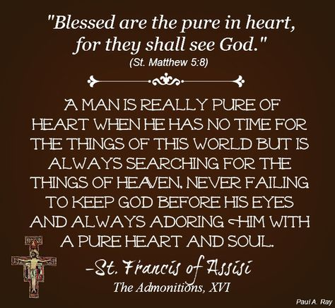

A point of reflection:
A possible place to reflect upon this purity of heart and pure light is to listen to this singing of the Franciscan Friars from the Basilica of St Francis for the Transitus of St Francis, entitled Cordia Pia: https://youtu.be/vnxO4q49EOA

So, let us pray:
That through the intercession of St. Francis we may be pure in heart, in order to see God and reflect the pure light of Christ, around us. Amen.

