‘Drawing nigh’
OFS Monthly Formation October 2021
St. Francis:
“Seeing his last hour drawing nigh, he summoned all his brethren who were in the convent, and after having addressed some words of consolation to them, to mitigate the grief they felt for his death, he exhorted them to love God as a tender Father. Then he spoke to them for a long time on the care they should take to persevere in the faith of the Church of Rome, in poverty and in patience, under the tribulations which awaited them, as well as in successes of their holy undertaking. He made use of the most moving expressions in recommending to them to make progress towards eternal goods, to be armed with vigilance against the dangers of the world, and to walk exactly in the paths of Jesus Christ; remarking to them that the observance of His Gospel was the basis and essence of their Institution, and that all their practices had this in view.” (From the Life and Legends of Saint Francis of Assisi, by Fr. Chalippe O.F.M.) 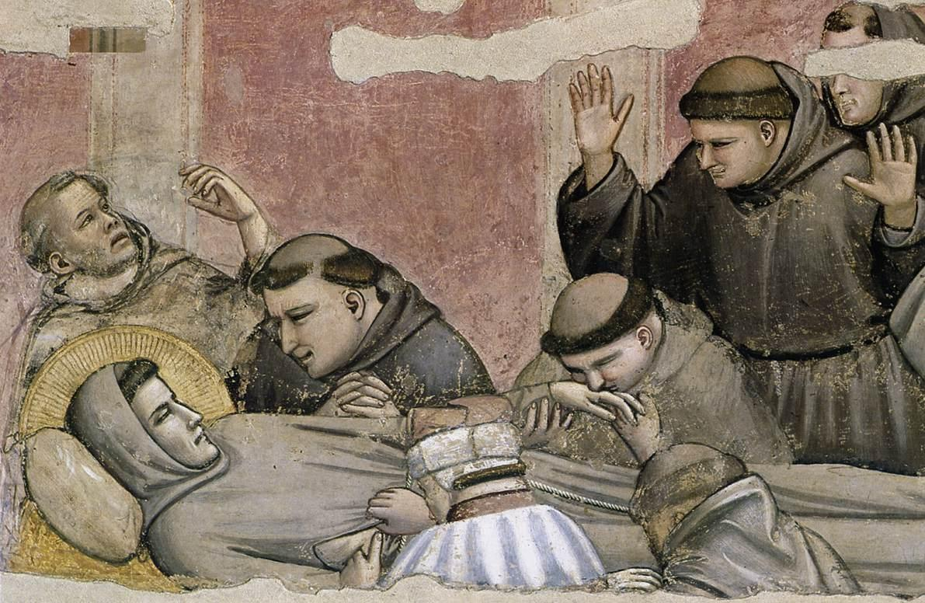 Death and Ascension of St. Francis - Giotto
Transitus:
Times of transition are never easy and yet they are necessary, in order to move forward on the journey towards eternal life. This is evidenced by the wise words of Saint Francis, above, in his Transitus to eternal life. They would appear to be apt for today and this period of transition here in New Zealand, as much as ever.

Words of Br. Elias (in relation to the Transitus):
“Do not mourn beyond all measure; for God, the Father of orphans, will comfort us with his holy consolation. And if you weep, brethren, weep for yourselves but not for him; for in the midst of our life we are in death, while he has passed from death to life.”

The Gospel:
“For what does it profit a man, to gain the whole world and forfeit his life?” (Mk 8:36)
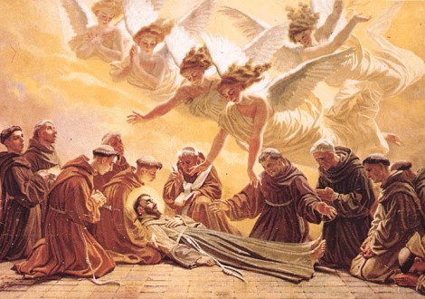
Francis left this earth a poor and lowly man:
He enters heaven rich in God’s favor.

A point of reflection:
Life’s journey would seem to be a series of many deaths (dying to self, to the world etc; as St. Francis exhorts us to do) and many new births into life in the Holy Spirit, which is rightly to be experienced as Franciscans, once so aptly named the Third Order of Brothers and Sisters of Penance. Yet, not without difficulty, pain and many ‘crucifixions/deaths’ along the way. Yet this is the pathway to eternal life and these transitions are part of the journey to our final Transitus.

So, let us pray:
To bear what must be born, with humility and courage, for without the cross, where would we be? Yet, with, in, and through the cross, is the way to Glory and so we pray dear Lord, hold onto our trembling hands and be with us today, St. Francis guide us on the way. Amen.

