‘The imprint of the Most High’
OFS Monthly Formation September 2021

Saint Francis bore the imprint of the Most High, in his stigmata, which we commemorate each year on September 17th. The question arises, how else might one see the imprint of the Most High in our world?
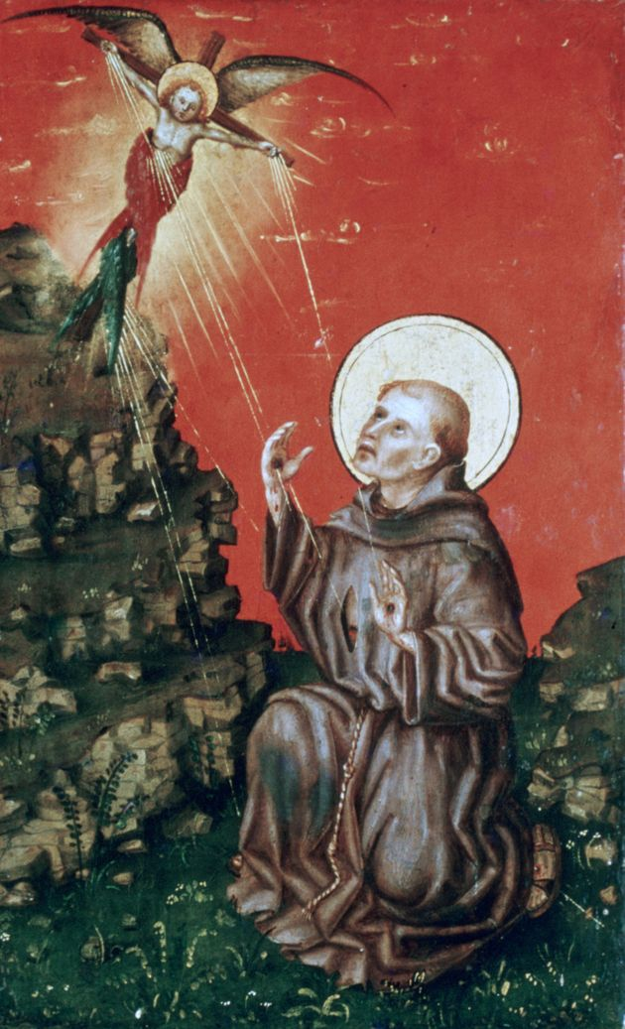

Rule 18:
With reference to the writings of I Celano 80, quoted in the Rule, it states that Franciscans “should respect all creatures, animate and inanimate, which ‘bear the imprint of the Most High’, and they should strive to move from the temptation of exploiting creation to the Franciscan concept of universal kinship”.

St. Francis:
The thought occurs, during this time of Alert Levels, where some may be privileged to slow down and have time to reflect more and observe nature, what could be learnt? Indeed, Francis was graced to commune with God, the Creator, through His creatures. Certainly, we are called as Franciscans to give praise and thanks to our Creator as our Seraphic Father Francis did. Interestingly, in reference to his motivation to write his Canticle of Brother Sun, Francis explained to Brother Leo “we do not praise, as we should, our Creator and the giver of all good”.

Pope Francis:
Pope Francis, in establishing the “World Day of Prayer for the Care of Creation”, from September 1 to October 4, 2021, (the Feast of St. Francis) in addition to asking us to consider our responsibility in the care of creation, asks that we “be thankful for God’s wonderful handiwork which he has entrusted to our care”.

The Gospel:
As Franciscans, called to go from Gospel to Life and Life to Gospel, it may be helpful to reflect upon the words of our Lord Jesus Christ in His Sermon on the Mount; “Look at the birds of the air: they neither sow nor reap, nor gather into barns, and yet your heavenly Father feeds them. Are you not of more value than they?” (Mt 6:26).

A point of reflection:
In the midst of our current nationwide challenges, what if one were to praise God more, to take time to find the imprint of the Most High in the graceful fluttering of a butterfly, the tuis sweet song, the variances of light at sunset, and in the sparrows that humbly commune together (and for whom our heavenly Father provides)?
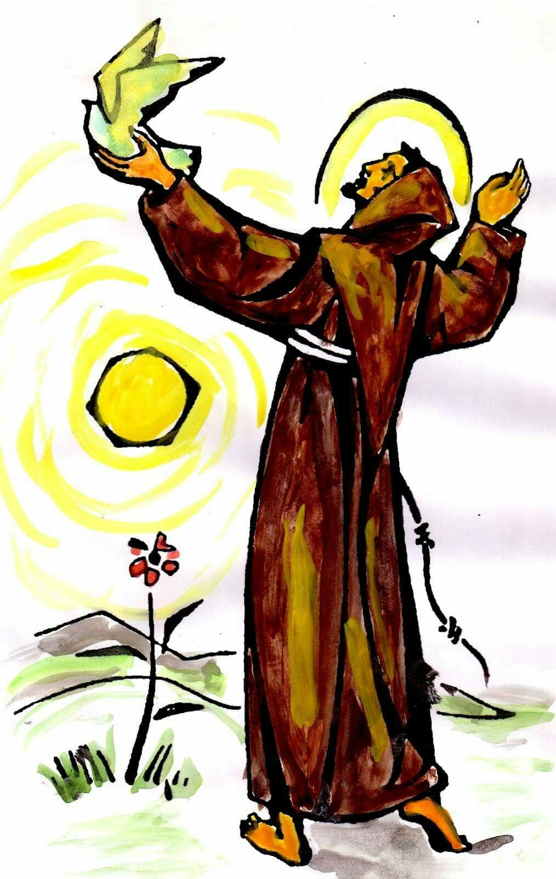

‘I am God’s creature of Him I am a part, I feel His love, awakening my heart’.
(A line from Donovan’s Song, ‘Brother Sun, Sister Moon’)

So, let us pray:
For the grace, in the midst of whatever circumstances we find ourselves in, to praise God in His creation, and to hear what the Spirit might be saying to us at this time, through the imprint of the Most High in His creatures.

