THE TRANSITUS (DEATH) OF SAINT FRANCIS
Used with permission from Kathleen White SFO (U.S.A)
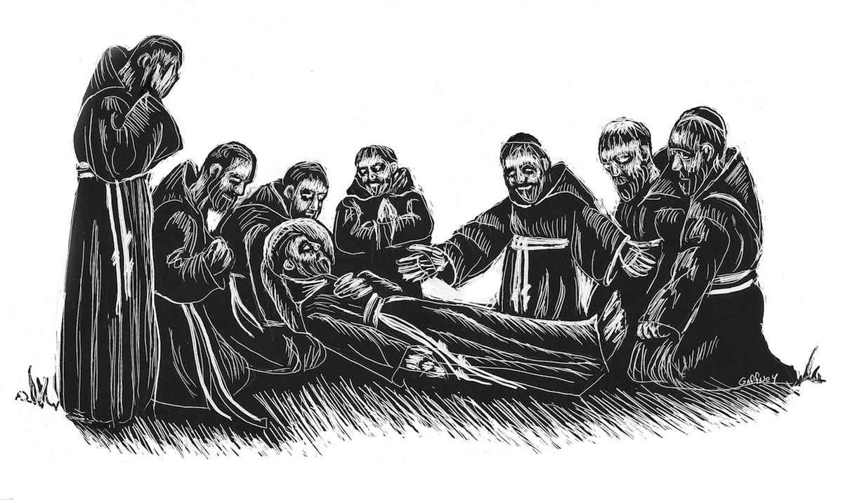Saint Francis died just after sunset on October 3. He recited Psalm 142 and during the closing verse, he died. This event is solemnly recalled each year by Franciscans to honour their holy Father’s entrance into joy. We invite you to commemorate this night.

TRANSITUS SERVICE IN ONE’S OWN HOME

The following observance may be done in the privacy of your own home or with a few others in your living room or parlour.
Light two candles and have a relic or image of St. Francis available.
Begin with Evening Prayer 1 from the Liturgy of the Hours. If you do not have the Liturgy of the Hours or do not know how to pray it, pray instead the Fourth and Fifth Sorrowful Mysteries of the Rosary, ‘The Crucifixion of Jesus’ and “The Death of Jesus on the Cross.’
Read the following excerpt from Francis’s Testament given shortly before he died:
The Testament of Saint Francis (1226)
I worked with my own hands, and I am still determined to work, and with all my heart I wish to have all the rest of the brothers work at employment that can be carried out without scandal. Those who do not know how to work should learn, not because they want to get something for their efforts, but to give good example and to avoid idleness. And should the wages of our work not be given to us, we can turn to God’s table and beg alms from door to door. God revealed a form of greeting to me, telling me that we should say, “God give you peace.”
Pause for a few moments of silent reflection.
Venerate (kiss or touch) the Relic or image of St. Francis.
An appropriate hymn or song may be sung.
The following antiphon is said:
Alleluia, Alleluia, Francis, poor and humble, enters heaven rich and is welcomed with celestial hymns. Alleluia.
Then follows Psalm 142:
¹ A maskil of David, when he was in the cave. A prayer.
² With full voice I cry to the LORD; with full voice I beseech the LORD.
³ Before God I pour out my complaint, lay bare my distress.
⁴ My spirit is faint within me, but you know my path. Along the way I walk they have hidden a trap for me.
⁵ I look to my right hand, but no friend is there. There is no escape for me; no one cares for me.
⁶ I cry out to you, LORD, I say, You are my refuge, my portion in the land of the living.
⁷ Listen to my cry for help, for I am brought very low. Rescue me from my pursuers, for they are too strong for me.
⁸ Lead me out of my prison, that I may give thanks to your name. Then the just shall gather around me because you have been good to me.
Glory to the Father and to the Son and to the Holy Spirit, as it was in the beginning, is now, and will be forever. Amen.
The Antiphon is repeated:
Alleluia, Alleluia, Francis, poor and humble, enters heaven rich and is welcomed with celestial hymns. Alleluia.
Blow out the candles to signify the death of Saint Francis.
Then, having in mind St. Francis’ devotion to the wounds of our Lord, and looking at the figure of the Crucified, with arms outstretched, say five times the prayer of Our Lord:
Our Father Who art in heaven, hallowed by Thy Name. Thy Kingdom come, Thy Will be done, on earth as it is in heaven. Give us this day our daily bread and forgive us our trespasses as we forgive those who trespass against us. And lead us not into temptation, but deliver us from evil. Amen.
End with the following prayer:
O God, you granted our blessed Father Francis the reward of everlasting joy: grant that we, who celebrate the memory of his death, may at last come to the same eternal joy; through Christ our Lord. Amen.

